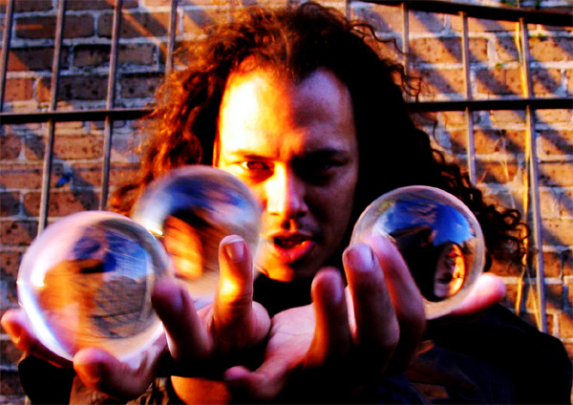

Thomas Wood - The Pyro Juggler - Skill and Danger! This hilarious show will tantalize your senses and tickle your funny bone as Thomas juggles torches, knives, bowling balls, crystal balls, full glasses of water, clubs and your hearts! He is renowned as a contact juggling specialist where crystal balls seem to float effortlessly over his body! This charismatic hodgepodge of comedy also includes fire eating, blowing, transferring, fire staff, and a finale that literally leaves an explosive mushroom cloud that sucks the oxygen out of the audience! http://pyrojuggler.net

